Journal Entries Application

## Instructions

Instructions for “Journal Entries Application”

**Please read and follow all the instructions for a proper use of the application!**

## Pre-requisites:

**Part 1. Pre-requisites (JE formats and maximum rows admitted):**

The journal entries can come in different configurations. The Journal Entries app works with the following JE file formats:

1. **CSS format (****Account/Amount Debit /Amount Credit**)

|  |  |  |
| --- | --- | --- |
| **Header name** | **Format** | **Example** |
| Account | General / Text | “101100” |
| Amount Debit | General / Number | **39,000** |
| Amount Credit | General / Number | **39,000** |

1. **CCS format (****Account Debit /Account Credit /Amount)**

|  |  |  |
| --- | --- | --- |
| **Header name** | **Format** | **Example** |
| Account Debit | General / Text | “101100” |
| Account Credit | General / Text | “101100” |
| Amount | General / Number | **39,000** |

1. **CCSS format (****Account Debit /Account Credit /Amount Debit /Amount Credit)**

|  |  |  |
| --- | --- | --- |
| **Header name** | **Format** | **Example** |
| Account Debit | General / Text | “101100” |
| Account Credit | General / Text | “101100” |
| Amount Debit | General / Number | **39,000** |
| Amount Credit | General / Number | **39,000** |

**Note: The maximum rows admitted in one file for JE will be 600K and always in xlsx format.**

**Part 2. Import files:**

* The current year Trial Balance file should be inported with the following header:

|  |  |  |
| --- | --- | --- |
| **Header name** | **Format** | **Example** |
| Account | General / Text | “101100” |
| Description | General / Text | “CAPITAL SOCIAL SUBSCRIS NEVARSAT” |
| OB | General / Number | **39,000** |
| DM | General / Number | **0** |
| CM | General / Number | **0** |
| CB | General/Number | **39,000** |

* Based on the configuration of the Journal Entries, choose the appropriate header for the Journal Entries file to be inported:

1. **CCSS(format)**

|  |  |  |
| --- | --- | --- |
| **Header name** | **Format** | **Example** |
| Account Debit | General / Number | “101100” |
| Account Credit | General / Number | “101100” |
| Description | General / Text | “CAPITAL SOCIAL SUBSCRIS NEVARSAT” |
| JE Number | General / Number | “310” |
| Date | Date | “31/12/2020” |
| Amount Debit | General / Number | **39,000** |
| Amount Credit | General / Number | **39,000** |

1. **CSS(format)**

|  |  |  |
| --- | --- | --- |
| **Header name** | **Format** | **Example** |
| Account | General / Number | “101100” |
| Description | General / Text | “CAPITAL SOCIAL SUBSCRIS NEVARSAT” |
| JE Number | General / Number | “310” |
| Date | Date | “31/12/2020” |
| Amount Debit | General / Number | **39,000** |
| Amount Credit | General / Number | **39,000** |

1. **CCS(format)**

|  |  |  |
| --- | --- | --- |
| **Header name** | **Format** | **Example** |
| Account Debit | General / Number | “101100” |
| Account Credit | General / Number | “101100” |
| Description | General / Text | “CAPITAL SOCIAL SUBSCRIS NEVARSAT” |
| JE Number | General / Number | “310” |
| Date | Date | “31/12/2020” |
| Amount Credit | General / Number | **39,000** |

## Instructions:

1. After connecting to the platform, go to **Journal Entries**:

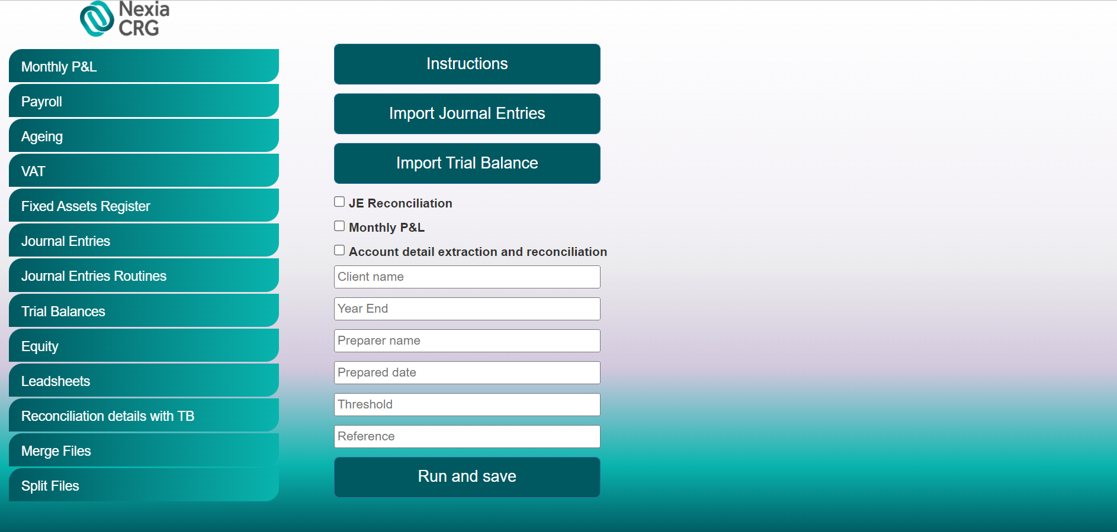

1. Enter the client’s name and the period end (MM/DD/YYYY) of the audit (Year End).
2. Click “Import Journal Entries” button and select the Journal Entries file.
3. Click “Import Trial Balance” and import the Trial Balance file.
4. Select the desired test which must be performed by app.

The 3 tests available in the App are:

* **JE Reconciliation** – The JE File is reconciled with the Trial Balance provided.
* **Monthly P&L** – Based on the JE File, the app creates a Monthly P&L file and reconciles it with the Trial Balance
* **Account detail extraction and reconciliation** – Segments the expenses/revenues accounts based on Synt(3) accounts and reconciles it with the Trial Balance

1. Insert the Preparer Name, Prepared Date, Threshold for account detail extraction and lastly, the Reference.
2. Click “Run and Save”. Once clicking that, the robot will ask the desired saving location, will process your request and download the excel test/s selected.

For any issues, questions and/ or suggestions, please contact:

Cristian Iordache, [cristian.iordache@ro.gt.com](mailto:cristian.iordache@ro.gt.com)

Bogdan Constantinescu, [bogdan.constantinescu@ro.gt.com](mailto:bogdan.constantinescu@ro.gt.com)